# Table of Contents

Contents

Table of Contents 1

Important Links 2

SmartPac 3 wiki 2

SmartPac 3 gPar setting 2

SmartPac 5 wiki 2

SmartPac 5 gPar settings 2

Material Setup 3

I/O Link version or Item Too Large - Please Remove Item From Bag And Cycle Machine Without Product Once 6

Ultrasonic sensor version (for 3.x machines) 6

1.16 - Gripper Adv/Ret Cycle Fault 7

Kickout “The scanned box barcode is not valid” 8

HMI not showing data after update 9

ASIN Tote Supply conveyor empty and/or Machine Starved warnings on HMI 10

# Important Links

## SmartPac 3 wiki

* <https://w.amazon.com/index.php/FCShip/SmartPac>

## SmartPac 3 gPar setting

* <https://w.amazon.com/bin/view/FCShip/SmartPac#g_Par_Definitions_.28Machine_Option_Settings.29>

## SmartPac 5 wiki

* <https://w.amazon.com/bin/view/FCShip/SmartPac/Version5_x/>

## SmartPac 5 gPar settings

* <https://w.amazon.com/bin/view/FCShip/SmartPac/Version5_x/#Hg_ParDefinitions28MachineOptionSettings29>

# Material Setup

Check the configuration on the HMI

* only one (1) box should be green
* options are read-only – changes must be made through the PLC as noted further down

SmartPac 3 HMI

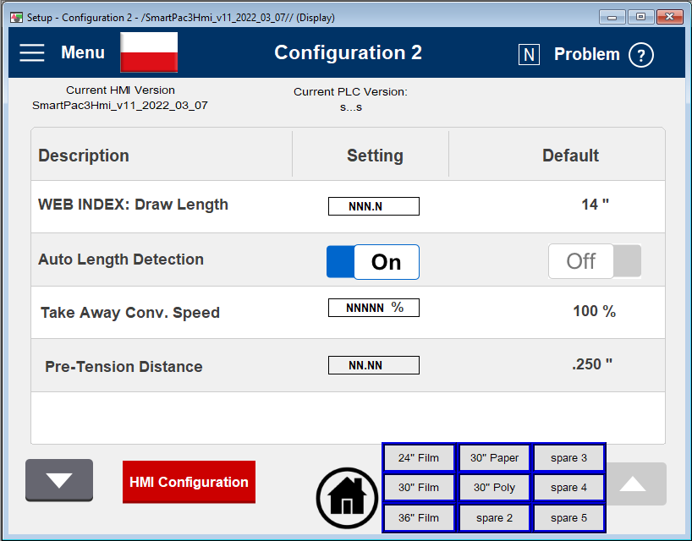

SmartPac 5 HMI

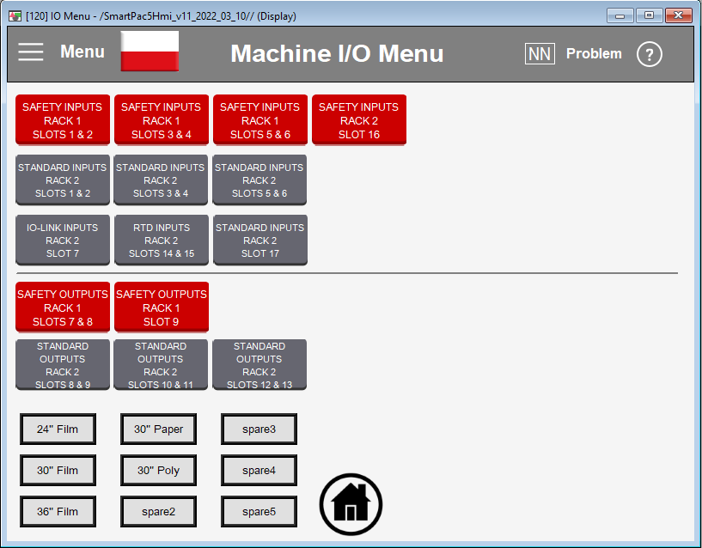

Only the config for the material you are running should be active (ON). Typically, this is g_par_FilmWidth30in as shown in the screen shot below

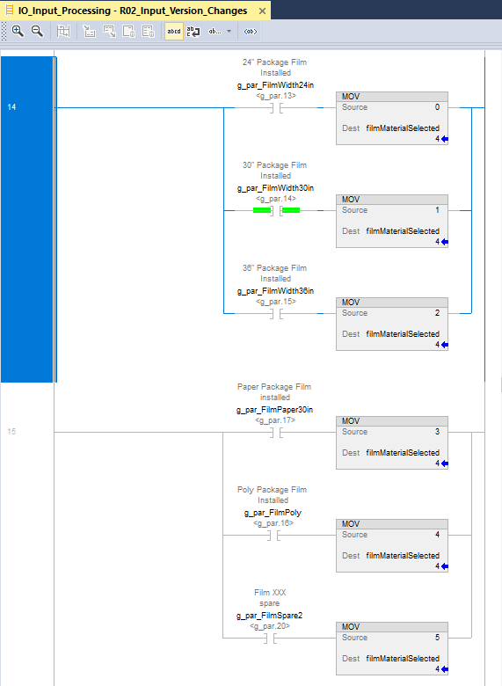

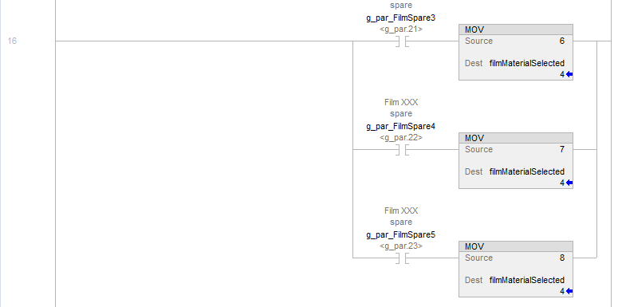

# I/O Link version or Item Too Large - Please Remove Item From Bag And Cycle Machine Without Product Once

* Visually verify ultrasonic sensor version – sensors are under cover above induct pocket
* Set g_par.18 to match the sensor version
  + IO Link 1.0
    - Pico+25/WK/F, Pico+35/WK/F
    - g_par.18 ON (1)
  + IO Link 1.1
    - Pico+25/WK/F/A, Pico+35/WK/F/A
    - g_par.18 ON (1)

# 

# Ultrasonic sensor version (for 3.x machines)

Toggle the g_par bit to indicate the IO Link version of ultrasonic sensor installed on the machine (g_par.18)

IO Link version 1.0 – Pico+25/WK/F, Pico+35/WK/F

IO Link version 1.1 – Pico+25/WK/F/A, Pico+35/WK/F/A

Front sensor model number (close to operator) : Pico+25/WK/F Rear sensor model number (away from operator): Pico+35/WK/F - IO Link version 1.0 **(g_par.18 ON)**

Front sensor model number (close to operator): Pico+25/WK/F/A Rear sensor model number (away from operator): Pico+35/WK/F/A – IO Link version 1.1 **(g_par.18 OFF)**

Note sensors have to be either both IO Link version 1.0 or both IO Link version 1.1.

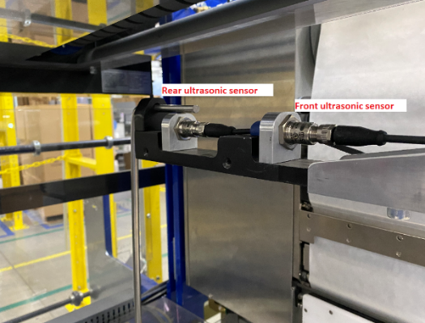

# 1.16 - Gripper Adv/Ret Cycle Fault

* Indicates the gripper advance (move to right) cylinder advance reed switch is not working
* It is suggested that this sensor be repaired
* If you choose not to repair the sensor, enable g_par.24

# Kickout “The scanned box barcode is not valid”

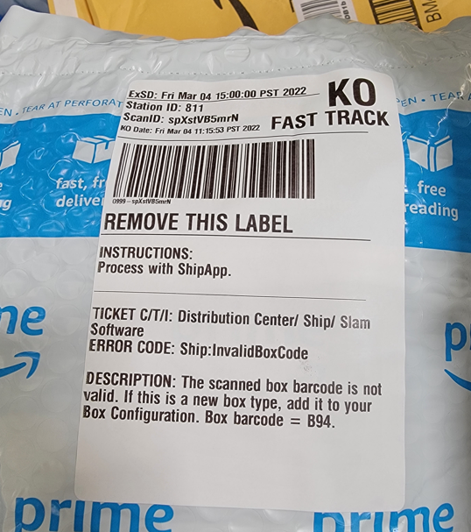

# HMI not showing data after update

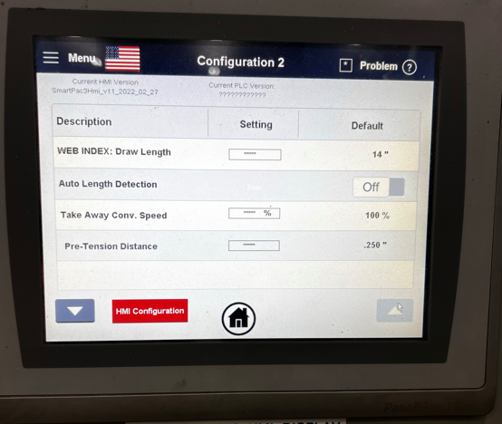

Update HMI firmware

<https://drive.corp.amazon.com/folders/SmartPac/Code%20Repository/02_HMI%20Code/SmartPac%203.x/firmware>

# ASIN Tote Supply conveyor empty and/or Machine Starved warnings on HMI

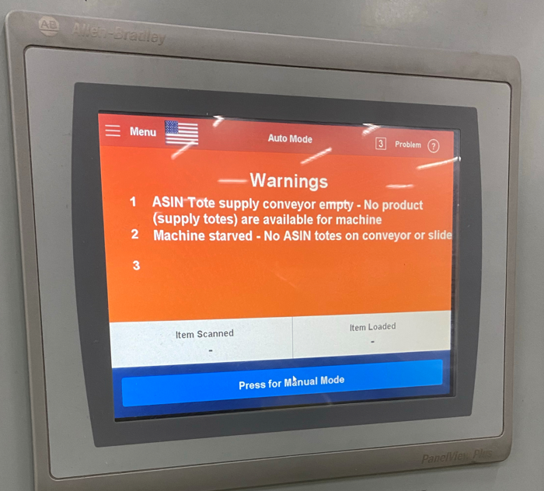

This is likely due to sensors being light activated vs dark activated.

* gPar.7 and gPar.8 allow inverting the sensor if needed. <https://w.amazon.com/index.php/FCShip/SmartPac#g_Par_Definitions_.28Machine_Option_Settings.29>
* Setup Information

<https://w.amazon.com/index.php/FCShip/SmartPac#OEE_Starved_Condition_Definition>